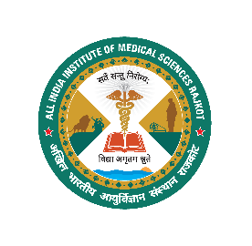
अखिल भारतीय आयुर्विज्ञान संस्थान राजकोट, गुजरात
All India Institute of Medical Sciences, Rajkot, Gujarat
A Central Autonomous Body under PMSSY, MoH & FW
Government of India www.aiimsrajkot.edu.in
Department of_____________________
____________________________________________________________________________________________________________

Lecture Hall / Conference Room booking form

Kindly permit us to use Lecture Hall / Conference Room as per the following details.

Date: _________________ | Time: ________________ | Duration: ______________

Lecture Hall No./ Conference Room: __________________ (Please tick as appropriate)

Approximate Number of Audience: ___________________________

Name of the Event: _________________________________

Purpose: _________________________________________

Contact Number: ____________________________________________

Date:________ | Name, Sign. & Stamp of Requisitioner: | Sign. & Stamp of HoD/In-charge:

For Office Use

Availability of time slot: Yes ▢ No ▢

Allotted Lecture Hall / Conference Room: _____________________

Verified By: ________________________________________

Approved By: ______________________________________

